**Project Title:** Visualizing and Predicting Heart Diseases with an Interactive Dash Board

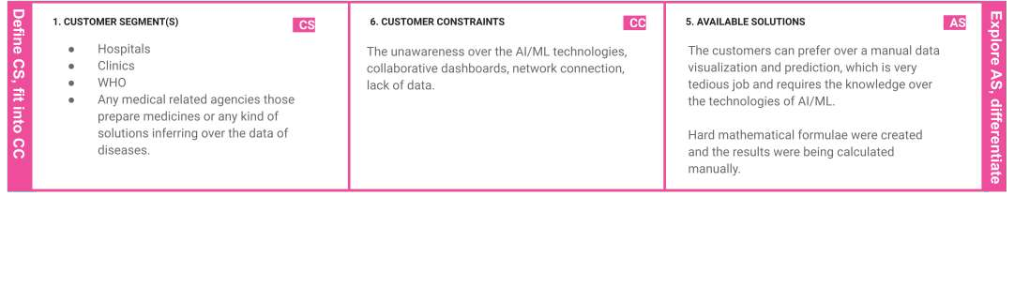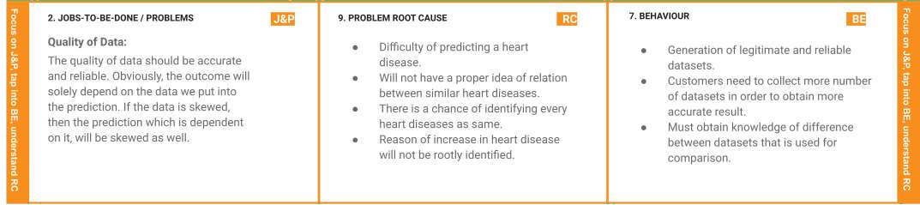

**Project Design Phase-I** - **Solution Fit Template Team ID:**  **PNT2022TMID23140**

